Chapter 6, Solution 29.

(a) C in series with C = C/(2)

C/2 in parallel with C = 3C/2

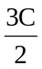in series with C = 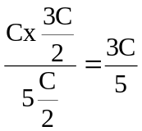

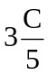in parallel with C = C + 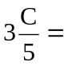 1.6 C

(b)
C_{eq}
2C
2C

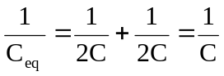

C_{eq} = 1 C

